***TechnicalArchitecture***

Project Design Phase- IITechnologyStack(Architecture&Stack)

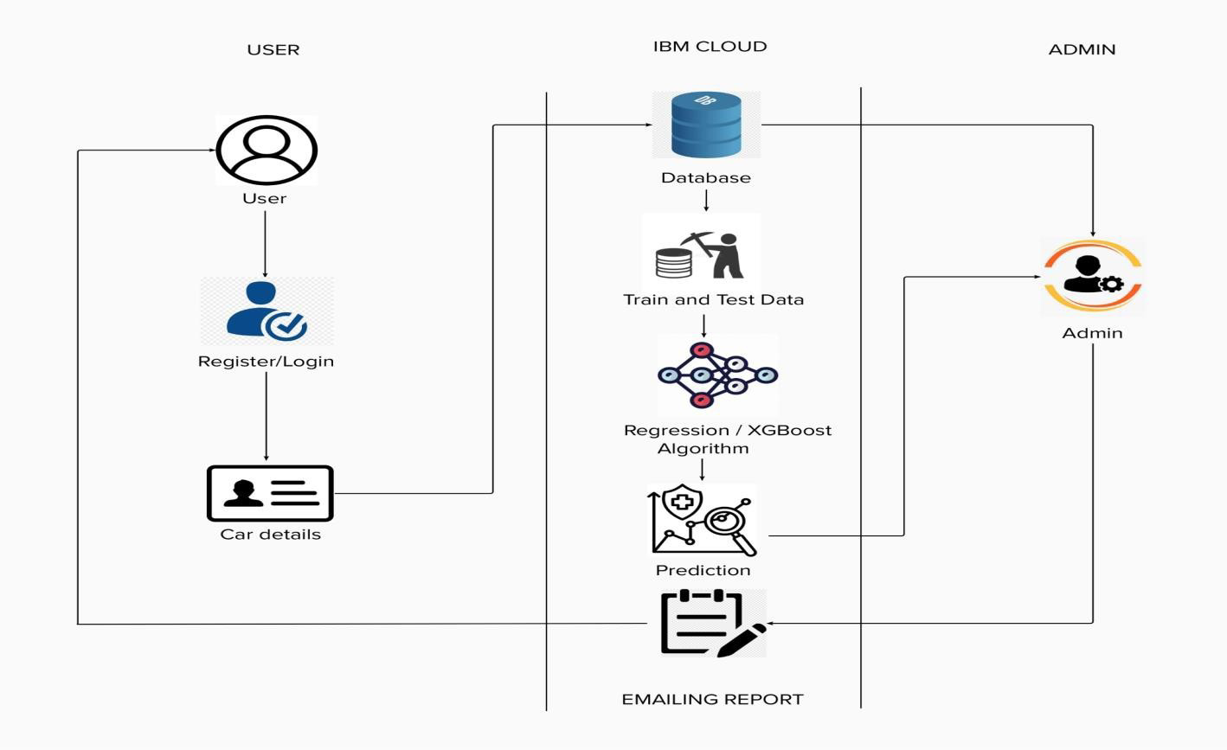

***Table-1:Components&Technologies:***

| ***S.No*** | ***Component*** | ***Description*** | ***Technology*** |
| --- | --- | --- | --- |
| *1.* | *UserInterface* | *Theuserinteractswithapplicationusing WebUI.* | *HTML,CSS,JavaScript,etc.* |
| *2.* | *Database* | *Thedatasetcontainingcardetailsisusedfortrai ningthemodeltopredicttherate.* | *Pythonlibrarieslikenumpy,pandasetc.* |
| *3.* | *CloudDatabase* | *ThedatasetisstoredintheIBMcloud* | *IBMCloud* |
| *4.* | *MachineLearningalgorithms* | *Themachinelearningalgorithmsareusedto predicttheusedcarsrate.* | *XGBoostorRegressionalgorithm* |
| *5.* | *Chart* | *Theuserwillreceivethepredictionchart* | *SMTP* |

***Table-2:ApplicationCharacteristics:***

| ***S.No*** | ***Characteristics*** | ***Description*** | ***Technology*** |
| --- | --- | --- | --- |
| *1.* | *Open-SourceFrameworks* | *Open-sourceframeworksused* | *PythonFlask,Python,IBMCloud* |
| *2.* | *SecurityImplementations* | *Authenticationprocessimplementation* | *Encryptions.* |
| *3.* | *ScalableArchitecture* | *Scalabilityofarchitectureconsistsof3tiers* | *Webserver- HTML,CSS,JavascriptApplicationser ver-PythonFlask*  *Databaseserver-IBMCloud* |
| *4.* | *Availability* | *Theusercanaccessthroughcloud* | *IBMCloudhosting* |
| *5.* | *Performance* | *Multipleuserscanaccessthewebapplication* | *IBMLoadBalance* |